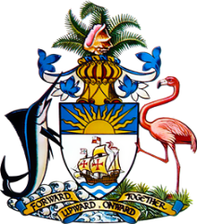

Statement by Ms. Sasha Dixon, Second Secretary
Permanent Mission of The Bahamas to the United Nations Office and other International Organizations in Geneva
at the 41st Session of the Universal Periodic Review Working Group
Presentation of UPR Report by the Government India
10 November 2022

Thank you, Mr. President.

We thank the delegation of India for its report and commend progress made since the last review.

In a constructive spirit, The Bahamas recommends that India:

- Accelerate efforts to ratify the UN Convention Against Torture
- Scale up efforts to address food insecurity among women and poor and vulnerable children, including by tackling root causes such as social norms which contribute thereto
and
- Bring domestic legislation in line with the provisions of the Convention on the Rights of Persons with Disabilities
We positively recognize efforts by India to promote a fair and inclusive society, including through its extensive food safety-net programmes and commend the commitment of India to providing developmental assistance and capacity-building to other countries and regions, such as the provision of vaccines during the pandemic, which benefitted countries such as The Bahamas.
We wish India a successful UPR.

I thank you.

