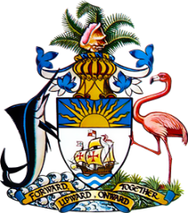

Statement by H.E. Patricia Hermanns, Ambassador/Permanent Representative
Permanent Mission of The Bahamas to the United Nations Office and other International Organizations in Geneva
at the 41st Session of the Universal Periodic Review Working Group
Presentation of UPR Report by the Government of the United Kingdom of Great Britain and Northern Ireland
10 November 2022

Thank you, Mr. President.

We thank the UK delegation for its report and commend progress made since the last review.

In a constructive spirit, The Bahamas recommends that the UK:

- Ensure that any reform of the 1998 Human Rights Act does not reduce the scope of protection or remedies currently enjoyed
- Take concrete steps to reduce rates of racially motivated hate crimes and discrimination faced by Afro-descendent and other ethnic minorities, including in Scotland and Northern Ireland, while ensuring that perpetrators do not enjoy impunity
and
- Accelerate efforts to achieve the objective of net zero carbon emissions by 2050, including by ensuring the mobilization of adequate resources for this purpose
We commend recent indications of support for consideration of climate reparations as well as efforts undertaken to narrow the gender and ethnicity pay gaps, respond to women’s specific health needs and address child poverty.
We wish the UK a successful UPR.

