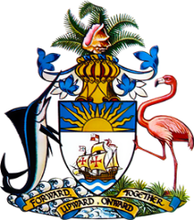

Statement by Ms. Sasha Dixon, Second Secretary
Permanent Mission of The Bahamas to the United Nations Office and other International Organizations in Geneva
at the 41st Session of the Universal Periodic Review Working Group
Presentation of UPR Report by the Government South Africa
16 November 2022

Thank you, Mr. President.

We thank the delegation of South Africa for its report and commend progress made since the last review. This includes criminal justice reforms, measures to combat corruption and legislative steps to improve women’s rights by eradicating harmful cultural practices. Successes achieved in the area of women’s political participation and in reducing maternal mortality are also noteworthy.

In a constructive spirit, The Bahamas recommends that South Africa:

- Develop and implement a holistic and broad ranging strategic response, including the provision of socio-economic packages, skills building programmes, psychosocial support and specialized services for survivors to prevent and address violence against children, including child homicides and attempted homicides

and

- Ensure all public schools have access to clean water, sanitation facilities and electricity, including in rural areas
We wish South Africa every success in this UPR process.

I thank you.

