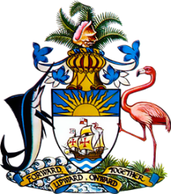

Statement by Ms. Sasha Dixon, Second Secretary
Permanent Mission of The Bahamas to the United Nations Office and other International Organizations in Geneva
at the 41st Session of the Universal Periodic Review Working Group
Presentation of UPR Report by the Government Brazil
14 November 2022

Thank you, Mr. President.

The Bahamas thanks the delegation of Brazil for its report and commends progress made since the last review, particularly in those areas in which recommendations were made by The Bahamas during the last UPR cycle. These efforts include expanded programs to combat violence against women and increased investment in programmes combatting HIV and AIDS.

In a constructive spirit, The Bahamas recommends that Brazil:

- Develop and implement a comprehensive strategy to address structural racism, discrimination, inequality, lack of access to justice and other root causes which contribute to the disproportionate representation of people of African descent, including Afro-descendent women, in incarceration

and

- Create and maintain a safe and enabling environment that is conducive to the exercise of the rights to peaceful assembly and association
We wish Brazil every success in this UPR process.

I thank you.

