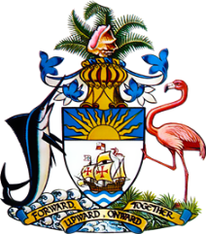

Statement by H.E. Ms. Patricia Hermanns
Ambassador and Permanent Representative of The Bahamas to the United Nations Office and Other International Organizations in Geneva
at the 41st Session of the Universal Periodic Review Working Group
Presentation of National Report by the Government of Ecuador
Monday 7 November, 2022

The Bahamas thanks Ecuador for presenting the national report and commends the country on progress made since the last review.
We congratulate Ecuador on positive steps taken to promote and protect human rights, including through the 2021-2025 Opportunity Creation Plan, with its objective of promoting sustainable resource use, climate change mitigation and ecosystem conservation inter alia. Moreover, efforts to promote universal access to information and communications technology and digital literacy along with targeted, inter-sectoral strategies to address poverty and chronic child undernutrition are noteworthy.

Notwithstanding the significant challenges arising from the COVID-19 pandemic, other commendable efforts include those aimed at improving health infrastructure, reducing child and adolescent pregnancy, promoting universal access to education and implementing the 2019-2030 Action Plan against Trafficking in Persons.

In a constructive spirit, The Bahamas recommends that Ecuador:

- Ensure the financial sustainability of efforts to address chronic child malnutrition, including for indigenous peoples and rural populations

- Ensure that austerity measures do not inhibit the availability of necessary resources to maintain levels of access to health services and take steps to remedy inequalities in health indicators for people of African descent
and
- Strengthen policies to reduce school drop-out rates including through the development of targeted strategies to allow adolescent mothers to return to secondary school
We wish Ecuador every success in this UPR process.

I thank you.

