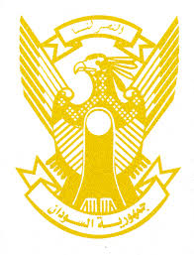
Sudan’s Statement on South Africa’s Universal Periodic Review during 41st UPR Working Group
Delivered by H.E Ambassador Hassan Hamid Hassan Permanent Representative of the Republic of the Sudan
16 November 2022
ــــــــــــــــــــــــــــــــــــــــــــــــــــــــــــــــــــــــــــــــــــــــــــــــــــــــــــــــــــــــــــــــــــــــــــ
Thank you, Excellency,
Sudan welcomes the distinguished delegation of South Africa headed by H.E. Mr. John Jeffery, Deputy Minister of Justice and Constitutional Development and thank them for their report.
Sudan appreciates the positive steps taken by South Africa in the context of promotion and protection of human rights including upholding and promoting Nelson Mandela Rules for the Treatment of Prisoners domestically and internationally, adopting its National Action Plan to Combat Racial Discrimination, Xenophobia and related Intolerance.
Sudan recommends South Africa to continue its efforts aimed at ensuring access to potable water, healthcare services and improving livelihoods, especially in rural areas.
We wish South Africa all success and continuous progress.

