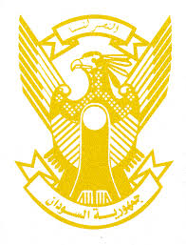
Sudan’s Statement on Indonesia’s Universal Periodic Review during 41st UPR Working Group
Delivered by
H.E Ambassador Hassan Hamid Hassan Permanent Mission of the Republic of the Sudan, 9 November 2022
ــــــــــــــــــــــــــــــــــــــــــــــــــــــــــــــــــــــــــــــــــــــــــــــــــــــــــــــــــــــــــــــــــــــــــــ
Thank your Excellency,
Sudan welcomes the Indonesia Minister of Law and Human Rights and the accompanied delegation.
Sudan appreciates the commitment of Indonesia to promote and protect human rights though implementing its National Action Plan on Human Rights, cooperation with and support to the OHCHR as well as its engagement with regional and international mechanisms including the Human Rights Council.
Indonesia has proved its solid adherence to the SDGs which addresses the most important component of human rights. It indicated steady progress in areas such as health coverage, poverty eradication, taking measures to ensure better life to the vulnerable communities and groups.
Sudan recommends that Indonesia consider ratifying and acceding to the human right’s related agreements such as 1951 Convention Relating to the Status of Refugees and its 1967 Protocols and the International Convention for the Protection of All Persons from Enforced Disappearance.

