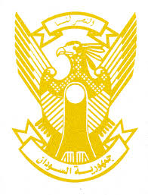
Sudan’s Statement on India’s Universal Periodic Review during 41st UPR Working Group
Delivered by
H.E Ambassador Hassan Hamid Hassan Permanent Representative of the Republic of the Sudan,
10 November 2022
ــــــــــــــــــــــــــــــــــــــــــــــــــــــــــــــــــــــــــــــــــــــــــــــــــــــــــــــــــــــــــــــــــــــــــــ
Thank you, Excellency,
Sudan welcomes the progress made by India since its last UPR. India has proved its solid adherence to the SDGs which addresses the most important component of human rights. The report submitted by India indicated steady progress in areas such as provision of health services, housing, potable water supplies, clean energy, poverty eradication, taking measures to ensure better life to the vulnerable communities and groups.
Sudan recommends that India consider ratifying and acceding to the 1951 Convention Relating to the Status of Refugees and its 1967 Protocols, Convention Against Torture (CAT) and the International Convention on Enforced Disappearance.
We wish India all success and continuous progress.

