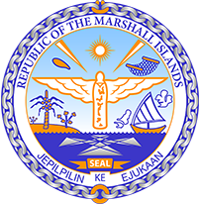

Republic of the Marshall Islands
STATEMENT by Mr. Samuel L. Lanwi Jr., Deputy Permanent Representative
41st Session, Universal Periodic Review
10 November 2022
Geneva
United Kingdom of Great Britain & Northern Ireland

Check against delivery
Thank you, Mr. President.
The Republic of the Marshall Islands warmly welcomes the UK delegation
to this 4th UPR cycle.
We are concerned about the adverse impacts of climate change across the globe not just in the most vulnerable countries but also in developed metropolitan countries such as the UK which has recently taken a toll on infrastructure and clearly signals serious consequences for future generations if left unabated.
In the spirit of constructive engagement, we recommend the following:
1. Sign the Declaration on Children, Youthand Climate Action and accelerate efforts to achieve “net zero” no later than2050.
2. Intensify efforts to address the harmful effects of fracking, environmental pollution, and climate change, to ensure that all persons can enjoy a clean, healthy, and sustainable environment.
3. Remove structural barriers to racial and ethnic minority communities’ equal and non-discriminatory enjoyment of human rights, including the right to health and the right to an adequate standard of living.
4. Resolve all outstanding issues related to the Chagos archipelago through inclusive dialogue with all concerned.
We wish the UK delegation a successful UPR during this 4th cycle.
Kommol tata & and I thank you, Mr. President.

