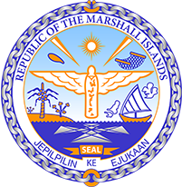

Republic of the Marshall Islands
STATEMENT by Mr. Samuel L. Lanwi Jr., Deputy Permanent Representative
41st Session, Universal Periodic Review
9 November 2022
Geneva
Indonesia

Check against delivery

Thank you, Mr. President.
The Republic of the Marshall Islands warmly welcomes the delegation of Indonesia to its 4th UPR cycle. We commend Indonesia’s ongoing humanitarian efforts during the pandemic including the disembarkation of over 500 Rohingya refugees. We also commend Indonesia for supporting several recommendations related to West Papua following its last UPR in 2017.
We note that while respect for human rights has generally improved, concerns remain about ongoing reports citing abuses and violations. As such, we share the concerns of various Special Rapporteurs on the dire human rights situation in West Papua.
Reaffirming the importance of open and constructive engagement and respecting Indonesia’s territorial integrity, we offer the following recommendations:
1. Respect, promote, and protect the human rights of all indigenous peoples in West Papua by ensuring their right to self-determination through inclusive dialogue;
2. Work closely with the OHCHR to commence a visit to West Papua by the High Commissioner in response to calls from the Pacific Islands Forum, the Organization of African, Caribbean, and Pacific States, and others;
4. Continue efforts to align its NDCs with the Paris Agreement goal of limiting global warming to 1.5 degrees Celsius above pre-industrial levels.
Kommol tata and I thank you.

