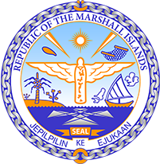

Republic of the Marshall Islands
STATEMENT by Mr. Samuel L. Lanwi Jr., Deputy Permanent Representative
41st Session, Universal Periodic Review
10 November 2022
Geneva

India

Check against delivery
Thank you, Mr. President.
The Republic of the Marshall Islands warmly welcomes the delegation of India to this 4th UPR cycle and thanks them for their well-prepared presentation. At the outset, we convey our condolences to the victims of the recent tragedy in Morbi. We urge the Government to continue to assist victims and their families, and to take precautions to avoid such tragedies in the future.
We constructively offer the following recommendations for India’s consideration:
1. Address caste-based discrimination against minorities by providing them with equal access to water and sanitation services and resources and through implementation of context-specific poverty alleviation programs.
2. Ensure that adequate resources are available to expedite adjudication of cases of violence against women.
3. Continue efforts to streamline its NDCs with the Paris Agreement goal of limiting global warming to 1.5 degrees Celsius above pre-industrial levels.
We wish the delegation every success during its 4th UPR cycle.
Kommol tata and I thank you, Mr. President.

