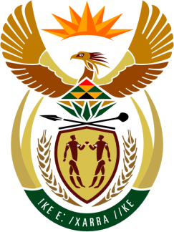

SOUTH AFRICAN PERMANENT MISSION
TO THE UNITED NATIONS
AND OTHER INTERNATIONAL ORGANISATIONS

41st SESSION OF THE WORKING GROUP ON THE
UNIVERSAL PERIODIC REVIEW

Review of POLAND

15 november 2022
09H00

(1 MINUTE 25 secONDS)

speaker no: 72

Check against delivery

Mr. President,

South Africa welcomes the distinguished delegation of Poland to this UPR Session and wishes the country a successful review.

South Africa is encouraged by Poland’s efforts to eliminate poverty and hunger including through the ‘Good Start and Family 500+ programmes that support children and families in rural areas as well as the 2019 to 2023 ‘Meals at School and at Home’ programme.

In order to ensure progress in promoting and protecting human rights, South Africa recommends that Poland:

- Ensure a comprehensive approach to combating sexual and gender-based violence and aligning national laws on domestic violence with international standards;

- Safeguard women’s sexual and reproductive health and rights (SRHR);

- Consider withdrawing its reservations to Articles 23 (1) (a) and (b), and Article 25 (a) of the Convention on the Rights of Persons with Disabilities (CRPD) which relate to matters of marriage, family, parenthood and relationships; as well as on access to health services;

- Strengthen measures to prevent racial hate crimes, the incitement of violence and related discriminatory behaviour against refugees, migrants, ethnic minorities, and the Roma; and

- Enhance measures, including through policy, to combat discrimination on the grounds of sexual orientation and gender identity.
I thank you

