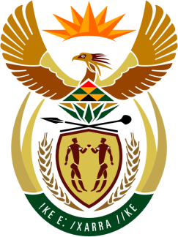

SOUTH AFRICAN PERMANENT MISSION
TO THE UNITED NATIONS
AND OTHER INTERNATIONAL ORGANISATIONS

41st SESSION OF THE WORKING GROUP ON THE
UNIVERSAL PERIODIC REVIEW

Review of Ecuador

7 november 2022

speaker no: 6

Check against delivery

Mr. President,

South Africa welcomes the distinguished delegation of Ecuador to this UPR Session and wishes Ecuador a successful review.

South Africa commends Ecuador on the 2021–2025 Opportunity Creation Plan, which is aligned with the 2030 Agenda for Sustainable Development and the Sustainable Development Goals and focuses on five thematic components: economic policy, social policy, comprehensive security, ecological transition, and institutional measures.

South Africa wishes to make the following recommendations:

- Ensure the right to free, prior, and informed consent of Indigenous peoples on policies, projects and legislation that may affect them, in line with human rights standards.

- Ensure timely and effective access to safe and legal abortion services for all pregnant people who need them.

- Continue efforts to enhance access to education in rural areas.

- Adopt age-appropriate comprehensive sexuality education and ensure it is a mandatory subject that is accessible to all students.

I thank you.

