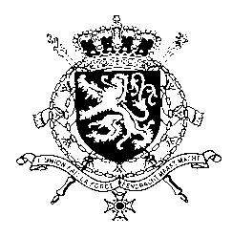
Représentation permanente de la Belgique auprès des Nations Unies et auprès des institutions spécialisées à Genève

WG UPR 41 – Philippines
Intervention of Belgium
7th November 2022

Mr. President,
While Belgium congratulates the Philippines for the adoption of its first national action plan on the safety of journalists and the adoption of the Anti-Child Marriage Law and the Anti-Online Sexual Abuse and Exploitation of Children Law, we would like to recommend the Philippines to:
R1. Hold accountable all perpetrators of violations against journalists, human rights defenders and citizens expressing their freedom of expression and strengthen the laws protecting journalists and human rights defenders against attacks, threats and killings;
R2. Intensify efforts in passing a comprehensive anti-discrimination law that protects all persons from all forms of discrimination based on sexual orientation, gender identity, gender expression and sexual characteristics (SOGIESC) in all settings;
R3. Take the necessary measures to ensure the effective implementation of the Anti-Child Marriage Law and the Anti-Online Sexual Abuse and Exploitation of Children Law ..
I thank you, Mr. President

