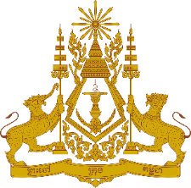
PERMANENT MISSION OF THE KINGDOM OF CAMBODIA
TO THE UNITED NATIONS AT GENEVA

Statement of Cambodia
At the 41st Session of the UPR Working Group
UPR of the Republic of the Philippines
14 November 2022
(01 minute and 05 seconds)
-------

Mr. President!

- Cambodia welcomes a free and orderly electoral process held in May 2022 with the highest voter turnout in the history of the Philippines.

- We commend recent initiatives taken by the government of the Republic of the Philippines in promoting and protecting human rights, including the well-being of its peoples through adoption of policies in the areas of education, climate change and energy.

- In the constructive spirit, Cambodia would like to put forward two recommendations:

  - Continue taking additional actions to further expand access to quality education by groups in disadvantage situations; and ensure inclusive and equitable quality education service.
  - Continue its efforts to implement effective disaster risk reduction measures to protect people living in rural areas, especially indigenous communities and most vulnerable groups.

- Finally, I wish the delegation of the Republic of the Philippines a successful review.

Thank you,

*****

