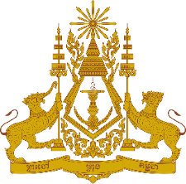
PERMANENT MISSION OF THE KINGDOM OF CAMBODIA
TO THE UNITED NATIONS AT GENEVA

Statement of Cambodia
At the 41st Session of the UPR Working Group
UPR of India
10 November 2022
(00 minute and 55 seconds)
-------

Mr. President!

- Cambodia recognizes India’s ongoing efforts to review legislations and to undertake legal reforms in line with its commitment to the international human rights obligations. Cambodia commends measures taken by India to implement recommendations since the adoption of its 3rd UPR report.

- In the constructive spirit, Cambodia would like to put forward two recommendations:
  - Continue the efforts and measures to increase safe and sustainable drinking water in rural area and to improve sanitation coverage, especially for indigenous communities and most vulnerable groups.
  - Continue efforts to promote women rights and to eliminate violence against women and girls through effective legislation and law enforcement measures.

- Finally, I wish the delegation of India every success in this review.

Thank you,

*****

