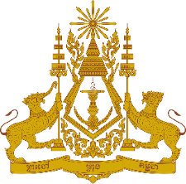
PERMANENT MISSION OF THE KINGDOM OF CAMBODIA
TO THE UNITED NATIONS AT GENEVA

Statement of Cambodia
At the 41st Session of the UPR Working Group
UPR of the United Kingdom of Great Britain and Northern Ireland
10 November 2022
(Allocated time: 1 min 00 second)

Mr. President,

- Cambodia commends the United Kingdom’s substantive progress in implementing recommendations from the previous cycle, including the adoption of measures and national strategy to combat violence against women and girls.

- My delegation recognizes the UK’s effective strategy in tackling human trafficking and the enhanced system protecting child victims.

- Cambodia would like to offer two recommendations for the United Kingdom’s consideration:
- Develop an effective employment policy for persons with disabilities aimed at ensuring decent work for them and equal pay for work of equal value
- Continue taking additional measures to increase opportunity for women to gain access to formal employment.

- I wish the delegation of the UK every success in this endeavour.

I thank you!
*****

