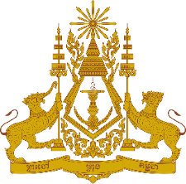
PERMANENT MISSION OF THE KINGDOM OF CAMBODIA
TO THE UNITED NATIONS AT GENEVA

Statement of Cambodia
At the 41st Session of the UPR Working Group
UPR of Finland
09 November 2022
(Allocated time: 1 min 15 seconds)

I thank you Chair,

- Cambodia commends Finland’s resolute commitment in fulfilling its human rights obligation, and recognizes Finland’s remarkable progress in implementing recommendations from the previous cycle.

- My delegation welcomes Finland’s endeavours to put in place various legislations, policies, action plans, and institutional mechanisms, including promoting employment opportunities for People with Disabilities and protecting victims of human trafficking.

- For further progress, Cambodia would like to offer three recommendations for Finland’s consideration:
- Encourage to place human rights at the core of any response to fight pandemic by fair distribution of vaccines, medicines, tools and remedies to all, without discrimination
- Continue taking efforts and measures to ensure a clearer and more efficient social security system, as required by the International Covenant on Economic, Social and Cultural Rights
- Consider adopting legislation obliging regions and municipalities to establish effective preventive measures to reduce and eliminate violence against women

- I wish the delegation of Finland every success in this exercise.

I thank you!
*****

