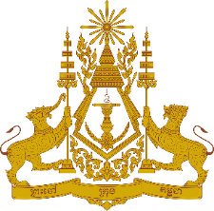
PERMANENT MISSION OF THE KINGDOM OF CAMBODIA
TO THE UNITED NATIONS AT GENEVA

Statement of Cambodia
At the 41st Session of the UPR Working Group
UPR of the Kingdom of Bahrain
07 November 2022
-------

Mr. President!
- Cambodia recognizes the Kingdom of Bahrain’s ongoing efforts to review legislations and to undertake legal reforms in line with its commitment to the international human rights obligations. Cambodia acknowledges the Kingdom of Bahrain’s continued engagements with UN human rights mechanisms, and special procedures.

- Cambodia commends several initiatives that the Kingdom of Bahrain has launched in order to promote rights to education, particularly women and girls as well as persons with disability, autism, mild intellectual disabilities or Down’s syndrome, during the outbreak of the COVID-19 pandemic.

- In the constructive spirit, Cambodia would like to put forward two recommendations:
  - Continue intensifying efforts to eliminate violence against women;
  - Consider taking additional steps to increase women’s representations at the decision-making levels.

- Finally, I wish the delegation of the Kingdom of Bahrain every success in this review.

Thank you,

*****

