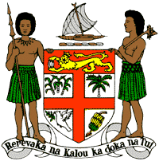
PERMANENT MISSION OF THE REPUBLIC OF FIJI TO THE UNITED NATIONS
OFFICE AND OTHER INTERNATIONAL ORGANISATIONS AT GENEVA

41st SESSION OF THE UPR WORKING GROUP

INDIA

Thursday 10 November 2022, 14:30 – 18:00
Speaking time: 00 minute and 55 seconds

Mr. President.
Fiji welcomes the delegation of India and commends the Government on its commitment to ratify the UN Convention against Torture (or UNCAT).
As a signatory to UNCAT since 1997, India’s strengthening of existing legal frameworks guaranteeing protection against torture, its widespread capacity building initiatives undertaken on torture prevention, as well as its acceptance in all three previous UPR cycles to ratify UNCAT, is encouraging and commendable.
As a core state of the Convention Against Torture Initiative, Fiji takes this opportunity to emphasize that the ratification and implementation of UNCAT would present India with the opportunity to further strengthen its national anti-torture framework, and to join the international community in united efforts against torture and ill-treatment.
It is in this spirit that Fiji recommends that the Government of India ratify the UN Convention against Torture.
I thank you.
140 words

