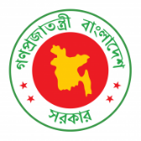
41th Session of UPR Working Group
Statement by Bangladesh in the Review of Morocco under 4th Cycle of UPR
08 November 2022, 14.30- 1800hrs.

Thank you, Mr. President,

Bangladesh warmly welcomes the distinguished delegation of Morocco to this UPR cycle.

Morocco’s determined efforts to implement the last UPR recommendations are visible. We appreciate Morocco for its continuous efforts in combatting violence against women, poverty, and trafficking.

In the spirit of cooperation, Bangladesh makes the following recommendations to Morocco:
- Continue its good work to improve the quality of education and reduce the rate of dropout in schools;

- Step up its efforts to ensure even greater participation by women in leadership roles.

We wish the delegation of Morocco success in its review

I thank you.
****

