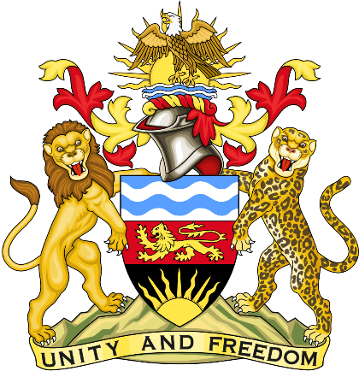

Statement delivered by the Mission of the Republic of Malawi to the United Nations and other International Organisations in Geneva

41st Session of the Working Group of the Universal Periodic Review

Review of Finland

9th November 2022

Mr. President,

Malawi welcomes Finland to this review and thanks the delegation for the comprehensive presentation.
Malawi applauds the steps taken by Finland on Climate change and other emerging issues. For any country to achieve Human Rights and the Sustainable Development Goals issues of Climate change, biodiversity and environmental degradation cannot be downplayed.
Malawi also commends Finland for the New Climate Act that entered into force in July 2022

In the spirit of constructive dialogue, Malawi makes the following recommendations to Finland:

- Consider ratifying the International Convention for the Protection of All Persons from Enforced Disappearance

- Consider ratifying the International Convention on the Protection of the Rights of All Migrant Workers and Their Families

- Consider aadvocating in regional and international organisations for universal, equitable, and affordable access to COVID-19 vaccines and drugs.

We wish Finland success at this review.

Thank you, Mr. President.

