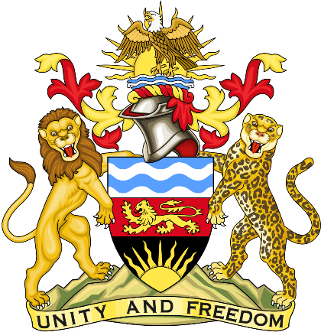

Statement delivered by Mission of the Republic of Malawi to the United Nations and other International Organisations in Geneva

41st Session of the Working Group of the Universal Periodic Review

Review of the Kingdom of the Netherlands

15th November 2022

Mr. President.

Malawi welcomes the Kingdom of the Netherlands to the review and thanks the delegation for a comprehensive presentation.

Malawi commends the Netherlands for the introduction of the Flexible Working Arrangements Act which aims at addressing the issues of financial inequality and improve the position of women in the labour market.

In the spirit of constructive dialogue, Malawi makes the following recommendations to Netherlands:

- Intensify efforts to increase the level of representation of women in decision-making positions, in particular the number of women mayors and members of company boards of directors.

- Consider acceding to the International Convention on the Protection of the Rights of All Migrant Workers and Members of their Families.

Malawi wishes the Kingdom of the Netherlands a successful review.

Thank you, Mr. President.

