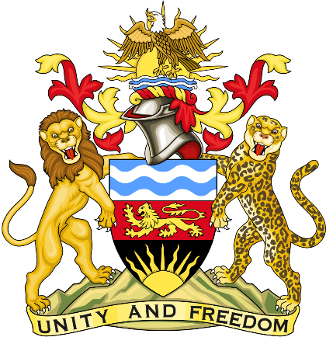

Statement delivered by the Mission of the Republic of Malawi to the United Nations and other International Organisations in Geneva

41st Session of the Working Group of the Universal Periodic Review

Review of the People's Democratic Republic of Algeria

11th November 2022

Mr. President,

Malawi welcomes the People's Democratic Republic of Algeria to this review and thanks the delegation for the comprehensive presentation.

Malawi recognises efforts by Algeria to establish the rule of law as seen in the adoption of the new Constitution by referendum in November 2020 which ushered in a new stage of institutional, political and socioeconomic reform in Algeria. Malawi also takes note of the efforts by Algeria in being inclusive in the amendment process of the Constitution by involving various key players such as politicians, associations, consultative bodies, prominent national figures, opinion-makers and religious leaders who served as constitutional experts in the review process.

In the spirit of constructive dialogue, Malawi makes the following recommendations to Algeria:

- Consider ratifying the International Convention for the Protection of All Persons from Enforced Disappearance.

- Uphold fundamental freedoms of assembly, expression and of the media to ensure inclusive participation in the political transition to democratic governance.

- Consider updating its anti-torture legislation in order to bring the definition of the crime of torture fully into line with the provisions of the International Covenant on Civil and Political Rights and accepted international standards and to ensure that, in all jurisdictions, forced confessions are prohibited and any evidence obtained through torture is inadmissible.

We wish the People's Democratic Republic of Algeria success at this review.

Thank you, Mr. President.

