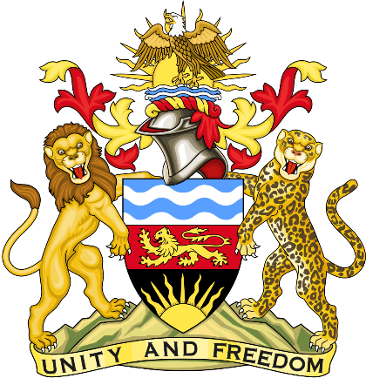

Statement delivered by the Mission
of the Republic of Malawi to the United Nations and other International Organisations in Geneva

41st Session of the Working Group of the Universal Periodic Review

Review of India

10th November 2022

Mr. President.

Malawi welcomes India to this review and thanks the delegation for the comprehensive presentation.

Malawi commends the progress India has made as regards to right to education backed by Article 21A of the Constitution of India which guarantees free and compulsory education of all children in the age group of six to fourteen years as a fundamental right. Malawi also takes note of the concerted effort that India has made to improve enrolment ratios in schools across India which has resulted in appreciable increase in the enrolment of children in India, from
261.63 million children in 2017-18 to 264.45 million children in 2020-21.

In the spirit of constructive dialogue, Malawi makes the following recommendations to India:

- Consider ratifying the Convention against Discrimination in Education.

- Consider aligning its legislation with the Education 2030 Framework for Action, which required States to ensure at least 12 years of free primary and secondary education, of which at least 9 were compulsory, and 1 year of free and compulsory pre-primary education.

- Address the digital gender and equity divide in education, ensuring that the right to education of all children was met through traditional and hybrid forms of education.

Malawi wishes the Republic of India a successful review.

Thank you, Mr. President.

