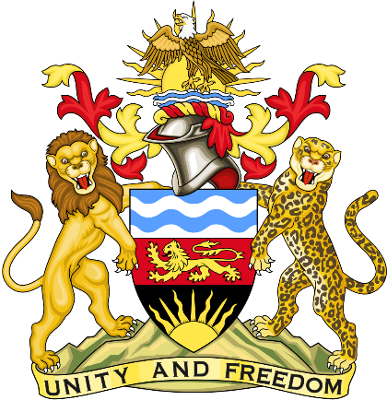

Statement delivered by the Mission of the Republic of Malawi to the United Nations and other International Organisations in Geneva

41st Session of the Working Group of the Universal Periodic Review

Review of the Republic of Indonesia

09th November 2022

Mr. President,

Malawi welcomes the Republic of Indonesia to this review and thanks the delegation for the comprehensive presentation.

Malawi recognises Indonesia’s efforts in promoting universal human rights norms through various initiatives and collaborations, including the Regional Conference on Humanitarian Assistance (2019 and 2021), the Regional Conference on Business and Human Rights (2021), and the Regional Seminar on the UN Convention Against Torture and Other Cruel, Inhuman or Degrading Treatment or Punishment (2019 and 2022).

In the spirit of constructive dialogue, Malawi makes the following recommendations to Indonesia:

- Should fast track the ratification the Optional Protocol of Convention against Torture and other Cruel, Inhuman or Degrading Treatment or Punishment.

- Should take decisive action towards investigating assaults against persons belonging to religious minorities and bring those responsible to justice.

- Should create an inductive environment for freedom of expression so that civil society activists and journalists are protected from violence and harassment for defending human rights and exercising.

We wish the Republic of Indonesia success at this review.

Thank you, Mr. President.

