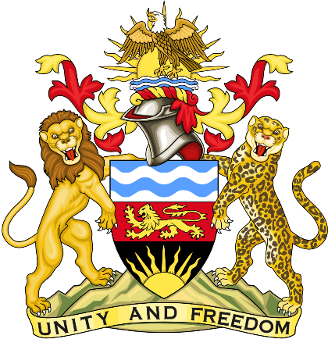

Statement delivered by Republic of Malawi Mission to the United Nations and other International Organisations in Geneva

41st Session of the Working Group of the Universal Periodic Review

Review of the Kingdom of Morocco

8th November 2022

Mr. President,

Malawi welcomes the Kingdom of Morocco to this review and thanks the delegation for the comprehensive presentation.

Malawi recognises the progress done by the Kingdom of Morocco that has so far been taken to protect children from diverse forms of neglect, violence and exploitation through its implementation of the integrated public policy for Child protection

In the spirit of constructive dialogue, Malawi makes the following recommendations to the Kingdom of Morocco:

- Progressively consider and in line with the priorities of the Kingdom, ratification of outstanding international human rights instruments.
- To consider establishing the Gender Parity and Anti Discriminatory Authority and the Advisory Council for Family and Children and providing adequate resources for those bodies to carry out their work.

We wish the Kingdom of Morocco success at this review.

Thank you, Mr. President.

