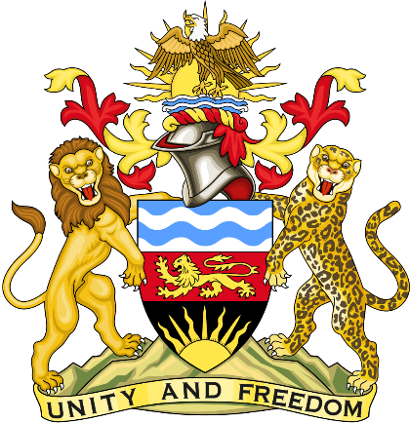

Statement delivered by the Mission of the Republic of Malawi to the United Nations and other International Organisations in Geneva

41st Session of the Working Group of the Universal Periodic Review

Review of the the Republic of South Africa
16th November 2022

Mr. President.

Malawi welcomes the Republic of South Africa to the review and thanks the delegation for a comprehensive presentation.

Malawi commends South Africa for its commitment to perform treaty obligations in good faith, including giving serious consideration to assessments on the implementation of regional, continental, and international human rights instruments by duly appointed supervisory bodies. Malawi also recognizes the impact of the COVID-19 pandemic on South Africa which has aggravated human rights linked to poverty, inequality and health.

In the spirit of constructive dialogue, Malawi makes the following recommendations to the Republic of South Africa:

- Consider ratifying the International Convention for the Protection of All Persons from Enforced Disappearance and the International Convention on the Protection of the Rights of all Migrant Workers and Members of their Families.

- Allocate adequate resources to the Commission for Gender Equality to enable the Commission carry out its mandate.

- Take effective measures to end xenophobia attacks

- Take effective measures to ensure the protection of human rights defenders

Malawi wishes the Republic of South Africa a successful review.
Thank you, Mr. President.

