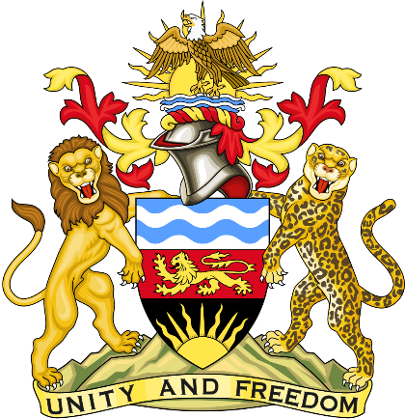

Statement delivered by the Mission of the Republic of Malawi to the United Nations and other International Organisations in Geneva

41st Session of the Working Group of the Universal Periodic Review

Review of the United Kingdom of Great Britain and Northern Ireland

10th November 2022

Mr. President.

Malawi welcomes the United Kingdom of Great Britain and Northern Ireland to the review and thanks the delegation for a comprehensive presentation.

Malawi commends the United Kingdom of Great Britain and Northern Ireland for the strides made in regards to |Combatting Violence Against Women and Girls (VAWG) by introducing new offences for controlling or coercive behaviour as well as raising the maximum penalties for harassment and ending the automatic early release of violent and sexual offenders from prison.

In the spirit of constructive dialogue, Malawi makes the following recommendations to the United Kingdom of Great Britain and Northern Ireland:

- To extend the applicability of the Equality Act of 2010 to Northern Ireland to ensure that it affords protection to women.
- The United Kingdom should not replace the Human Rights Act of 1998 with more limited legislation. The United Kingdom should rather maintain the same level of human rights protection provided by the Human Rights Act in the British Bill of Rights and include additional child-specific rights.

Malawi wishes the United Kingdom of Great Britain and Northern Ireland a successful review.

Thank you, Mr. President.

