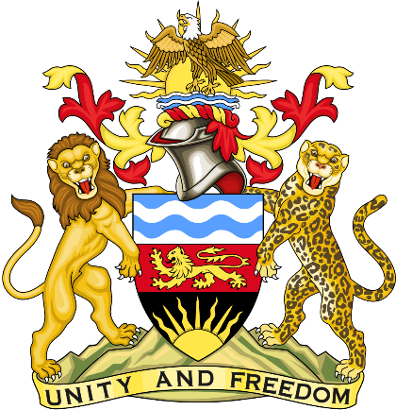

Statement delivered by the Mission of the Republic of Malawi to the United Nations other International Organisations in Geneva

41st Session of the Working Group of the Universal Periodic Review

Review of the Republic of Tunisia

8th November 2022

Mr. President,

Malawi welcomes the Republic of Tunisia to this review and thanks the delegation for the comprehensive presentation.
Malawi applauds the Republic of Tunisia in the establishment of a very extensive educational infrastructure network amongst other Africa and Arab countries. And for allocating a lot of resources in its budget to ensure the Right to Education is being fulfilled and ensuring there is inclusive and equitable quality education. Malawi believes that education remains the fundamental Human Right for everyone

In the spirit of constructive dialogue, Malawi makes the following recommendations to the Republic of Tunisia:

- Consider progressive ratification of outstanding international human rights instruments.

- To promptly finalise amendments to the Criminal Code and the Code of Criminal Procedure; ands amend legislation to prohibit the prosecution of civilians before military courts and ensure the effective independence of the judiciary.

We wish the Republic of Tunisia success at this review.

Thank you, Mr. President.

