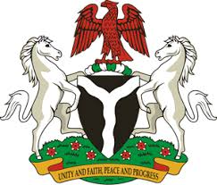

Please check against delivery

HUMAN RIGHTS COUNCIL
41ST SESSION OF THE UPR WORKING GROUP
STATEMENT
BY THE
FEDERAL REPUBLIC OF NIGERIA
ON THE
REVIEW OF THE KINGDOM OF THE NETHERLANDS

15TH NOVEMBER, 2022

Mr. President,
Nigeria welcomes the delegation of the Kingdom of the Netherlands to the presentation of its National Report and commends the commitment of the Government to the implementation of previous recommendations.
2. In the spirit of constructive dialogue, and to further ensure the protection of human rights for all, Nigeria wishes to make the following recommendations for the consideration of The Netherlands:
- To consider taking further necessary measures to ensure adequate protection of the rights of migrants, including through the ratification of the Convention on the Protection of the Rights of all Migrant Workers and Members of their Families;
- To scale up efforts to combat racism, racial discrimination and racial profiling; and
- To respect the rights of parents to raise and educate their children, in accordance with the Convention on the Rights of the Child.
3. Finally, Nigeria wishes The Netherlands a very successful review process.
I thank you Mr President.
******

