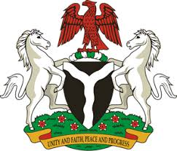

Please check against delivery

HUMAN RIGHTS COUNCIL
41ST SESSION OF THE UPR WORKING GROUP
STATEMENT
BY THE
FEDERAL REPUBLIC OF NIGERIA
ON THE
REVIEW OF PHILIPPINES

14TH NOVEMBER, 2022

Mr. President,
Nigeria warmly welcomes the delegation of the Philippines to the presentation of its National Report and commends the Government for its continued cooperation with human rights mechanisms and commitment to its international human rights obligations.
2. Nigeria takes very positive note of efforts made by the Government of Philippines to ensure the promotion and protection of rights and fundamental freedoms of its people, including the right to the life of the unborn. In addition, Nigeria commends the commitment of the Government to improve the socio-economic well-being of its people, through continued commitment to the implementation of the Philippines Development Plan (2017-2022).
3. In the spirit of constructive dialogue, Nigeria wishes to make the following recommendations for the consideration of the Government of Philippines:
- To remain committed to the full and effective implementation of the United Nations Joint Programme; and
- To scale up efforts in combatting human trafficking, and the protection of the rights of the victims of trafficking
4. Finally, Nigeria wishes Philippines a very successful review process.
I thank you.

