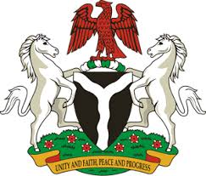

Please check against delivery

HUMAN RIGHTS COUNCIL
41ST SESSION OF THE UPR WORKING GROUP
STATEMENT
BY THE
FEDERAL REPUBLIC OF NIGERIA
ON THE
REVIEW OF BRAZIL

14TH NOVEMBER, 2022

Mr. President,
Nigeria welcomes the delegation of Brazil to the presentation of its National Report and commends the Government for its continued cooperation with human rights mechanisms.
2. Nigeria takes note of efforts made by the Government of Brazil to prevent and combat racism, racial discrimination and related intolerances, as well as in the promotion and protection of the rights of migrants.
3. In the spirit of constructive dialogue, therefore, Nigeria wishes to make the following recommendations for consideration by Brazil:
- To scale up efforts in combatting human trafficking, and ensure the protection of the rights of the victims of trafficking, particularly the children; and
- To further strengthen efforts to ensure the promotion and protection of the rights of migrants, through positive consideration of the ratification of the Convention on the Protection of the Rights of all Migrants and Members of their families
4. Finally, Nigeria wishes Brazil a very successful review process.
I thank you.

