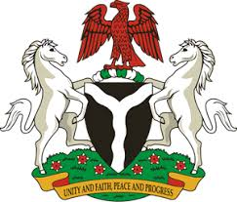

Please check against delivery

HUMAN RIGHTS COUNCIL
41ST SESSION OF THE UPR WORKING GROUP
STATEMENT
BY THE
FEDERAL REPUBLIC OF NIGERIA
ON THE
REVIEW OF THE PEOPLE’S DEMOCRATIC REPUBLIC OF ALGERIA

11TH NOVEMBER, 2022

Mr. President,
Nigeria warmly welcomes the delegation of the Brotherly People’s Democratic Republic of Algeria to the presentation of its National Report and commends the Government for its steadfast and continued cooperation with human rights mechanisms and commitment to its international human rights obligations.
2. Nigeria takes very positive note of efforts made by the Government of Algeria on counter-terrorism, prevention and deradicalization measures, particularly through the adoption of the national strategy to combat subversive acts and terrorism. In addition, we laud the measures adopted by the Government to combat corruption and trafficking in persons.
3. In the spirit of constructive dialogue, Nigeria wishes to make the following recommendations for the consideration of Algeria:
- To continue its efforts to protect its citizens from the scourge of terrorism; and
- To sustain its effort to strengthen institutional frameworks to safeguard the fundamental rights and freedom of its people.
4. Finally, Nigeria wishes Algeria a very successful review process.
I thank you.

