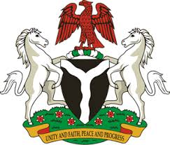

Please check against delivery

HUMAN RIGHTS COUNCIL
41ST SESSION OF THE UPR WORKING GROUP
STATEMENT
BY THE
FEDERAL REPUBLIC OF NIGERIA
ON THE
REVIEW OF THE UNITED KINGDOM OF GREAT BRITAIN AND NORTHEN IRELAND

10TH NOVEMBER, 2022

Mr. President,
Nigeria warmly welcomes the delegation of the United Kingdom to the presentation of its National Report and commends the commitment of the Government to the implementation of previous recommendations.
2. We take due cognisance of the efforts made by the Welsh Government to address racism, racial discrimination and hate crimes through its Anti-Racist Action Plan towards achieving an anti-racist Wales by 2030.
3. In the spirit of constructive dialogue, Nigeria would like to recommend to the Government of the United Kingdom as follows:
- To ratify the Convention on the Protection of the Rights of all Migrants Workers and Members of their families;
- To scale up efforts in ensuring elimination of racism and racial discrimination;
- To scale up efforts in combatting human trafficking, and the protection of the rights of the victims of trafficking; and
- To respect the rights of parents to raise and educate their children, in accordance with the Convention on the Rights of the Child
4. Finally, Nigeria wishes the United Kingdom a successful review.

I thank you.

