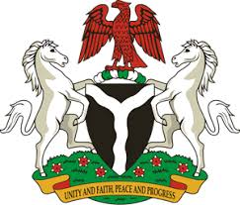

Please check against delivery

HUMAN RIGHTS COUNCIL
41ST SESSION OF THE UPR WORKING GROUP
STATEMENT
BY THE
FEDERAL REPUBLIC OF NIGERIA
ON THE
REVIEW OF THE REPUBLIC OF FINLAND

9TH NOVEMBER, 2022

Mr. President,
Nigeria warmly welcomes the delegation of Republic of Finland to the presentation of its National Report and commends the commitment of the Government to the implementation of previous recommendations.
2. Nigeria notes with encouragement, the adoption of initiatives by the Government of Finland to address racism and racial discrimination, particularly in the adoption of the Action Programme to combat racism and to promote good relations in 2021.
3. In the spirit of constructive dialogue, and to further ensure the protection of human rights for all, Nigeria wishes to make the following recommendations for the consideration of Finland:
- To consider taking further necessary measures to ensure adequate protection of the rights of migrants and refugees, including through the ratification of the Convention on the Protection of the Rights of all Migrant Workers and Members of their Families; and
- To respect the rights of parents to raise and educate their children, in accordance with the Convention on the Rights of the Child.
4. Finally, Nigeria wishes Finland a very successful review process.
I thank you Mr President.
******

