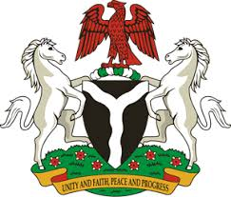

Please check against delivery

HUMAN RIGHTS COUNCIL
41ST SESSION OF THE UPR WORKING GROUP
STATEMENT
BY THE
FEDERAL REPUBLIC OF NIGERIA
ON THE
REVIEW OF THE KINGDOM OF MOROCCO

8TH NOVEMBER, 2022

Mr President,
Nigeria warmly welcomes the delegation of the Kingdom of Morocco to the presentation of its National Report and commends the Government for its continued cooperation with human rights mechanisms.
2. Nigeria further commends the Government of Morocco for the efforts exerted to strengthen its national human rights frameworks and mechanisms, as well as its democratic process, through the adoption of National Action Plans for Democracy and Human Rights.
3. In the spirit of constructive dialogue, Nigeria wishes to make the following recommendations for the consideration of the Government of the Kingdom of Morocco:
- To remain committed to the full and effective implementation of the justice system reforms charter; and
- To scale-up efforts in its fight against trafficking in persons and the promotion and protection of the rights of migrants and members of the families.
4. Finally, Nigeria wishes Morocco a very successful review process.

I thank you, Mr. President

