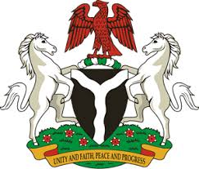

Please check against delivery

HUMAN RIGHTS COUNCIL
41ST SESSION OF THE UPR WORKING GROUP
STATEMENT
BY THE
FEDERAL REPUBLIC OF NIGERIA
ON THE
REVIEW OF THE REPUBLIC OF TUNISIA

8TH NOVEMBER, 2022

Mr President,
Nigeria warmly welcomes the delegation of the Republic of Tunisia to the presentation of its National Report and commends the Government for its steadfast and continued cooperation with human rights mechanisms and commitment to its international human rights obligations.
2. We commend the Government of Tunisia for the various concrete reforms adopted, such as the judicial and economic reforms, which seek to improve the socio-economic well-being of its citizens, as well as in strengthening the administration of justice. In addition, Nigeria takes positive note of the Government’s counter-terrorism measures, while recognising the imperative of upholding human rights.
3. In the spirit of constructive engagement, Nigeria wishes to recommend to the Government of Tunisia as follows:
- To continue its efforts to protect its citizens from the scourge of terrorism; and
- To ensure the protection of the rights of Migrants as the country works stridently to ratify the Convention on the Protection of the Rights of Migrant Workers and Members of their families.
4. In conclusion, we wish Tunisia a very successful review process.
I thank you Mr President.

