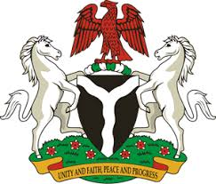

Please check against delivery

HUMAN RIGHTS COUNCIL
41ST SESSION OF THE UPR WORKING GROUP
STATEMENT
BY THE
FEDERAL REPUBLIC OF NIGERIA
ON THE
REVIEW OF THE KINGDOM OF BAHRAIN

7^{TN} NOVEMBER, 2022

Mr President,
Nigeria welcomes the delegation of the Kingdom of Bahrain to the presentation of its UPR National Report and commends the Government for its cooperation with human rights mechanisms and commitment to the implementation of previous recommendations.
2. We take positive note of the efforts taken by the Government to promote and protect human rights and fundamental freedoms within its borders, particularly in the promotion of freedom of religion, the rights of children, as well as in the advancement of the rights of women and girls.
3. In the spirit of constructive engagement, Nigeria wishes to recommend for consideration by the Government of Bahrain as follows:
- To ratify the Optional Protocol to the Convention against Torture; and
- To scale up efforts and commitments in upholding human rights and fundamental freedoms.
4. We wish Bahrain a very successful review process.
I thank you Mr. President.
******

