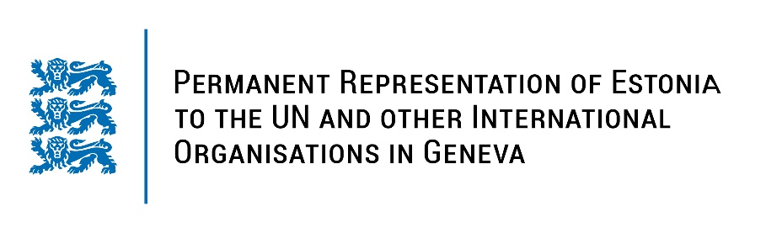
Universal Periodic Review of the Republic of South Africa
16 November 2022
Intervention by the delegation of Estonia

Estonia welcomes the delegation of South Africa to the 41st UPR session thanks for the report and the information provided today.

Estonia notes with appreciation the adoption of a National Action Plan (2019-2024) to combat racism, racial discrimination, xenophobia and related intolerance. We commend South Africa for the first national strategic plan to combat Gender Based Violence and femicide and for the adoption of related legislation. We also welcome the approval of the National Action Plan on Women, Peace & Security.

Estonia would like to recommend to South Africa to:
- ensure prosecution of violent crimes against vulnerable groups (women and children, LGBTQI+, refugees and migrants) by providing sufficient resources and by training law enforcement officials;
- continue fighting against sexual and gender-based violence, by improving women’s access justice, especially in rural areas;
- ensure accountability for the crimes of xenophobia by adopting a clear implementation framework for National Action Plan to combat racism, racial discrimination, xenophobia and related intolerance;
- improve school infrastructure and invest methodically in education to ensure solid options to those who are in less advantageous circumstances in terms of poverty and security.

Estonia wishes the delegation of South Africa a fruitful review meeting.

I thank you!

