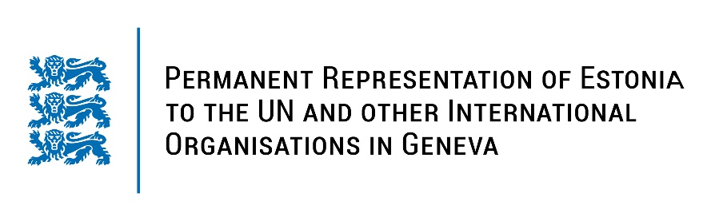
Universal Periodic Review of the Kingdom of the Netherlands
15 November 2022
Intervention by the delegation of Estonia

Estonia welcomes the delegation of the Kingdom of the Netherlands to the 41st UPR session and thanks for the report and the information provided today.

Estonia appreciates the Netherlands’ role in promoting human rights and a diversified level of human rights protection across the country. Estonia commends the Netherlands for introducing its second National Human Rights Action Plan in 2019. We applaud the Netherlands for its approach to fighting human trafficking and receiving, as the only country from the evaluated, an A-score in the Global Slavery Index. Estonia commends the Netherlands for its activities on LGBTIQ+ rights and takes the Netherlands as an example.

Estonia would like to recommend to the Netherlands to:
- further develop policies to prevent violence and harassment against journalists;
- consider a review of legislation to ensure the application of its child justice system to all children below the age of 18.

Estonia wishes the delegation of the Netherlands a successful review meeting.

I thank you!

