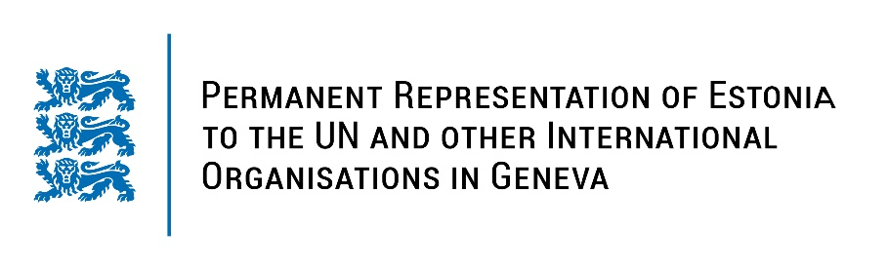
Universal Periodic Review of the Republic of Poland
15 November 2022
Intervention by the delegation of Estonia

Estonia welcomes the delegation of Poland to the 41st UPR session and thanks for the report and the information provided today.

Estonia appreciates Poland’s role in promoting human rights. Estonia commends Poland for the significant efforts undertaken to help refugees fleeing from the war Russia is waging on Ukraine. We applaud Poland for the progress made on implementing the third UPR recommendations.

Following up on our previous recommendations, Estonia would like to recommend to Poland to:
- ratify the Optional Protocol to the Convention on the Rights of Persons with Disabilities;
- strengthen measures to eradicate corporal punishment, within educational institutions and in the home;
- fully implement the Istanbul Convention on preventing and combating violence against women and domestic violence, to counteract domestic violence more effectively and to protect and support victims by improving services for them.

Estonia wishes the delegation of Poland a successful review meeting.

I thank you!

