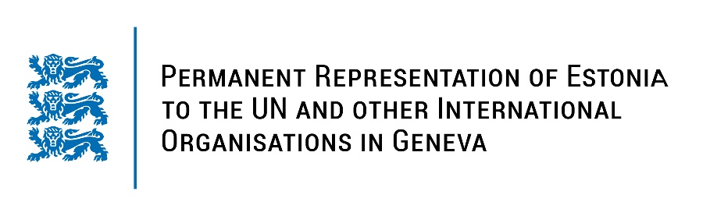
Universal Periodic Review of the Federative Republic of Brazil
14 November 2022
Intervention by the delegation of Estonia

Estonia welcomes the delegation of the Federative Republic of Brazil to the 41st UPR session and thanks for the report and the information provided today.

Estonia gladly notes that Brazil has welcomed the visits of Special Procedures and the Subcommittee on Prevention of Torture and Other Cruel, Inhuman or Degrading Treatment or Punishment. We welcome the ratifications of the Optional Protocol to the Convention on the Rights of the Child and ILO Convention on Domestic Workers. We note with appreciation Brazil’s efforts to welcome, help and integrate migrants and refugees.

Following up on our previous recommendations, Estonia would like to recommend Brazil to:
- implement the recommendations on Indigenous Peoples’ rights tabled at the 3rd UPR;
- continue fighting against gender-based and domestic violence, by training law enforcement and court officials in handling these cases and by improving women’ and girls’ access justice;
- adopt a plan with concrete steps and measurable targets to reduce deforestation, taking into account Indigenous Peoples’ rights and habitat;
- establish a national human rights institution in accordance with the Paris Principles.

Estonia wishes the delegation of Brazil a successful review meeting.

I thank you!

