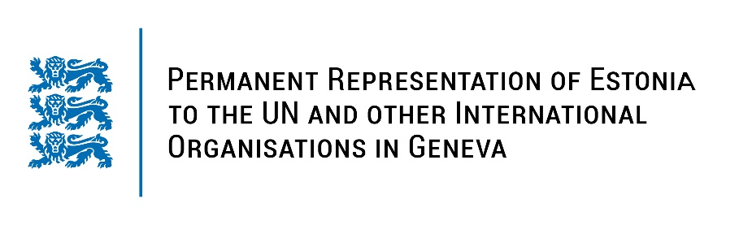
Universal Periodic Review of the Philippines
14 November 2022
Intervention by the delegation of Estonia

Estonia welcomes the delegation of the Philippines to the 41st UPR session and thanks for the report and the information provided today.

Estonia commends the Philippines on the reform on an adequate standard of living and on the progress of rights of women and children (Prohibition of Child Marriage Law, Act Raising the Age of Sexual Consent to 16, Expanded Maternity Leave Law). We note with appreciation the progress made on reducing child labour and enforcing the prohibition of slavery and trafficking in persons.

In line with our previous recommendations, Estonia would like to recommend to the Philippines to:
- ensure accountability for all the crimes, including enforced disappearances, extrajudicial killings, illegal arrests and detention and torture, committed in the connection with so-called war on drugs by conducting speedy and fair trials;
- ensure remedy and reparations for victims and their families;
- fully respect international human rights law in efforts to combat the trade in and use of illegal drugs;
- re-ratify the Rome Statute of the International Criminal Court;
- take all necessary measures to provide adequate protection to lawyers, human rights defenders, journalists and media workers, in particular regarding enforced disappearances and extrajudicial killings.

Estonia wishes the delegation of the Philippines a fruitful review meeting.

I thank you!

