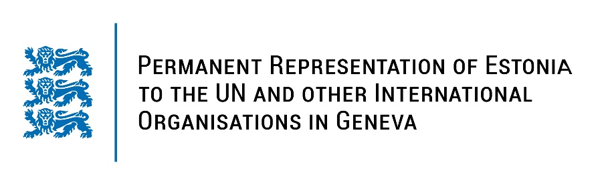
Universal Periodic Review of the People's Democratic Republic of Algeria
11 November 2022
Intervention by the delegation of Estonia

Estonia welcomes the delegation of Algeria to the 41st UPR session and thanks for the report and the information provided today.

Estonia notes with appreciation Algeria´s progress in the fight against human trafficking and steps taken to guarantee an adequate standard of living and right to social security. We are worried about human rights defenders, journalist and media workers who are detained or convicted for exercising their right to freedom of expression or peaceful assembly.

Estonia would like to recommend to Algeria to:
- ratify the Rome Statute of the International Criminal Court;
- ratify the first and the Second Optional Protocol to the International Covenant on Civil and Political Rights (ICCPR);
- ratify the Optional Protocol to the Convention against Torture and Other Cruel, Inhuman or Degrading Treatment or Punishment;
- take steps to ensure the full independence and impartiality of the judiciary by establishing an independent and objective process for appointing judges and public prosecutors and by reducing executive representation in judicial institutions;
- repeal overly broad and vaguely worded articles of the Penal Code that allow authorities to penalize freedom of expression.

Estonia wishes the delegation of Algeria a successful review meeting.

I thank you!

