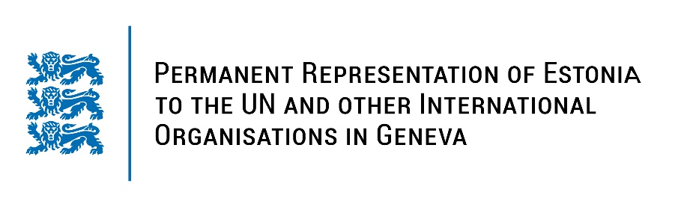
Universal Periodic Review of India
10 November 2022
Intervention by the delegation of Estonia

Estonia welcomes the delegation of India to the 41st UPR session and thanks for the report and the information provided today.

We welcome the efforts of the Government of India to tackle the poverty and ensure greater access to water and sanitation and the government’s commitment to the eradicate violence against women. Estonia gladly notes that India has ratified ILO convention no. 138 on Minimum Age to Employment and ILO convention no. 182 on the Worst Forms of Child Labour.

Estonia would like to recommend to India to:
- carefully review the Foreign Contribution (Regulation) Act and the Unlawful Activities (Prevention) Act to ensure freedom of expression, assembly and association and the protection of civil society organisations and human rights defenders;
- persistently work to ensure and protect independent judiciary and functioning human rights institutions;
- ratify the Convention against Torture and Other Cruel, Inhuman or Degrading Treatment or Punishment (CAT) and its Optional Protocol (OPCAT), the Second Optional Protocol to the International Covenant on Civil and Political Rights (ICCPR) and the Rome Statute of the International Criminal Court;
- accept a country visit from the Special Rapporteurs on Torture, Right to Privacy, Right to Freedom of Assembly and Association.

Estonia wishes India success in continuing the good work in the field of Human Rights.
I thank you!

