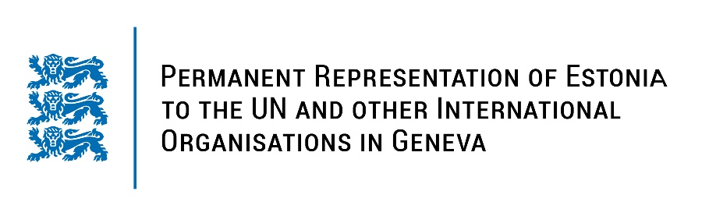
Universal Periodic Review of the United Kingdom of Great Britain and Northern Ireland
10 November 2022
Intervention by the delegation of Estonia

Estonia welcomes the delegation of the United Kingdom to the 41st UPR session and thanks for the report and the information provided today.

Estonia appreciates the United Kingdom’s role in promoting human rights around the world and a diversified level of human rights protection across the UK. Estonia commends the UK for introducing the new Domestic Abuse Act to ensure the protection of women and submitting the Online Safety Bill to Parliament to fight hate crime. We applaud the UK for ratifying the Council of Europe Convention on preventing and combating violence against women and domestic violence (Istanbul Convention) in 2022, and initiatives to improve prisons conditions as per the recommendations made in the third cycle of UPR.

Estonia would like to recommend to the UK to:
- ratify the First Optional Protocol of the International Covenant on Civil and Political Rights (OP-ICCPR);
- consistently implement International Covenant on Economic, Social and Cultural Rights by establishing a strategy for the eradication of child poverty;
- ensure the effectiveness and scope of 1998 Human Rights Act in any future legislation.

Estonia wishes the delegation of the United Kingdom of Great Britain and Northern Ireland a successful review meeting.

I thank you!

