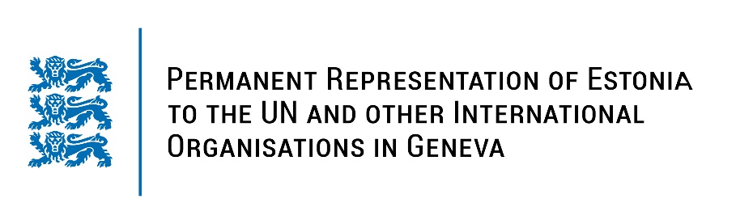
Universal Periodic Review on Finland
9 November 2022
Intervention by the delegation of Estonia

Estonia welcomes the delegation of Finland to the 41st UPR session and thanks for the report and the information provided today.

Estonia commends Finland on developing new legislative and policy measures and action plans to prevent and combat discrimination, to promote gender equality, to fight against gender-based violence and to combat hate speech and hate crimes. We particularly welcome the enactment of an Action Plan for Combating Violence against Women (2020-23) and the establishment of an independent national rapporteur on gender-based violence.

Following up on our previous recommendations, Estonia would like to recommend to Finland to:
- take further measures to address violence against women, by both encouraging the reporting of and improving the identification of the cases of violence against women and domestic violence;
- ensure that all law enforcement officials, prosecutors, judges and lawyers receive systematic mandatory training on fundamental and human rights, including appropriate training how to effectively deal with cases of violence against women;
- provide high-quality social and mental health services for children and young people and reinforce training in trauma and mental health of professionals working with children and young people.

Estonia wishes the delegation of Finland a fruitful review meeting.
I thank you!

