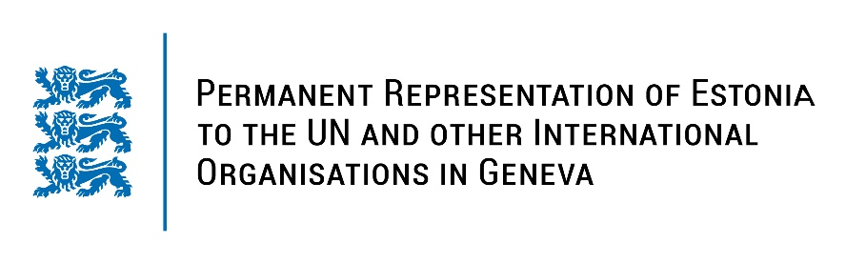
Universal Periodic Review on Indonesia
9 November 2022
Intervention by the delegation of Estonia

Estonia welcomes the delegation of Indonesia to the 41st UPR session and thanks for the report and the information provided today.

Estonia gladly notes the adoption of the fourth National Action Plan (NAP) for Human Rights and of legal provisions to safeguard the rights of women, children and persons with disabilities. We specifically commend Indonesia for passing the Sexual Violence Bill in 2022 to prosecute sex crimes and ensure accountability. Estonia understands that Indonesia struggles with previous UPR recommendations on the revision of the Criminal Code and Human Rights Law. Estonia respectfully urges Indonesia to constructively work on these important initiatives.

Estonia would like to recommend to Indonesia to:
- ensure freedom of opinion and expression by de-criminalizing libel, blasphemy and defamation;
- conduct impartial, thorough and effective investigations into all cases of attacks, harassment and intimidation against civil society activists, Human Rights Defenders, journalists and media workers;
- ratify the Second Optional Protocol to the International Covenant on Civil and Political Rights (ICCPR), aiming at the abolition of the death penalty;
- ratify the Optional Protocol to the Convention against Torture and Other Cruel, Inhuman or Degrading Treatment or Punishment.

Estonia wishes the delegation of Indonesia a fruitful review meeting and constructive engagement in this process.

I thank you!

