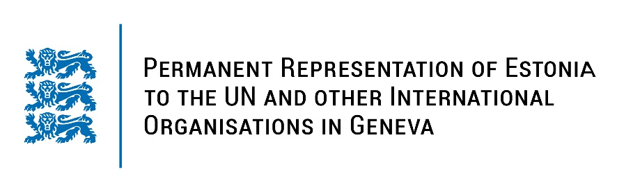
Universal Periodic Review of the Kingdom of Morocco
8 November 2022
Intervention by the delegation of Estonia

Estonia welcomes the delegation of the Kingdom of Morocco to the 41st UPR session and thanks for the report and the information provided today.

Estonia commends Morocco for the second Action Plan 2021–2023 of the initiative "Partnership for Open Government". We applaud Morocco for promoting women’s rights and establishing the National Committee for Gender Equality and the Advancement of Women, to institutionalize gender equality and women empowerment.

We now take the opportunity to reiterate some of our previous recommendations for the Kingdom of Morocco:
- to ratify the Second Optional Protocol to the International Covenant on Civil and Political Rights (ICCPR);
- to ratify the Rome Statute of the International Criminal Court.

In addition, Estonia would like to recommend to Morocco to:
- revise the Family Code in order to end discrimination during inheritance and divorce procedure;
- continue fighting against domestic violence and train law enforcement and court officials in handling domestic violence cases.

Estonia wishes the delegation of the Kingdom of Morocco a successful review meeting.

I thank you!

